Application: iMovie
System: Mac computer

Overview
Since I was 10 or so, I have been making short films using iMovie. It started as a silly hobby, but over time I attained more and more film experience. This opened up several opportunities in high school and in college, as my video editing skills were sometimes in demand for school projects. Because of my experience with iMovie, which started at a young age, I have edited and helped produced dozens of group projects, not to mention fostered a passive income through ad revenue on online videos. I think this app (or other similar movie-making apps) are great to introduce to students at a young age, and it can be a fun experience for both students and teacher.

Potential application
The possible applications of iMovie are pretty open-ended; a teacher could ask students to make a video presentation on a story or historical occurrence, or to make a short creative film that explains a math concept. In my practicum experience, I helped a teacher facilitate a project with iMovie. The students were to make a commercial for a protist (it was a life science class). The students were asked to include the following in the commercial:
- What the protist “does”
- Does it have cilia or flagella?
- Where is it found (habitat)
- What does it eat?

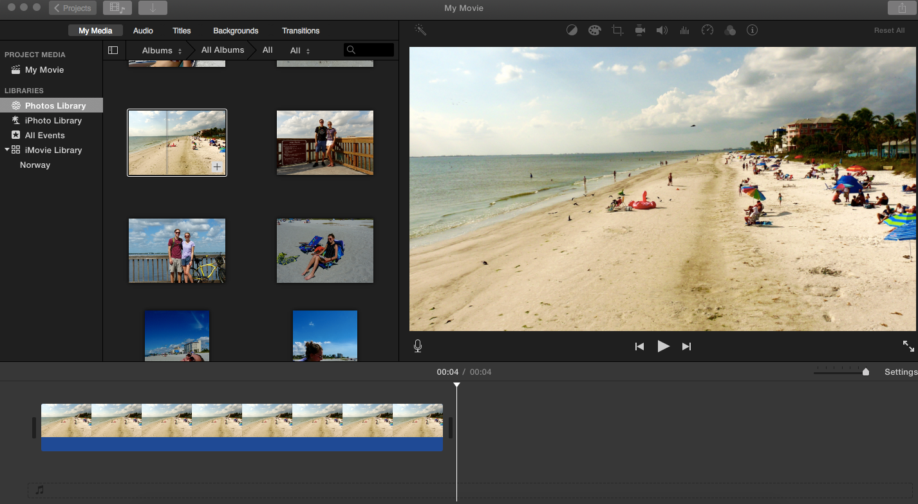
Figure 1: A screenshot of the iMovie workspace

SAMR
In my estimation, iMovie works effectively for Augmentation, Modification, and perhaps Redefinition. The “film” format is quite versatile, and could be used in several unique ways.
- Augmentation: An animated or virtual timeline could be described, or a poem/short story could be narrated with visuals
- Modification: Students each are assigned a role (director, writer) and must cooperate in a non-traditional group project format.
- Redefinition: Several groups could each make a video describing a cell process or structure, and these videos could be edited together to make a full film.

I think the best part of iMovie is that it allows for a wide range of complexity. Advanced, creative students can excel with a program such as iMovie, yet the app is user-friendly enough for even the most technology-impaired student (of which there are fewer and fewer). I hope that giving students experience with iMovie might at least present them with some of the opportunities I’ve had, as I wouldn’t trade them for anything.

